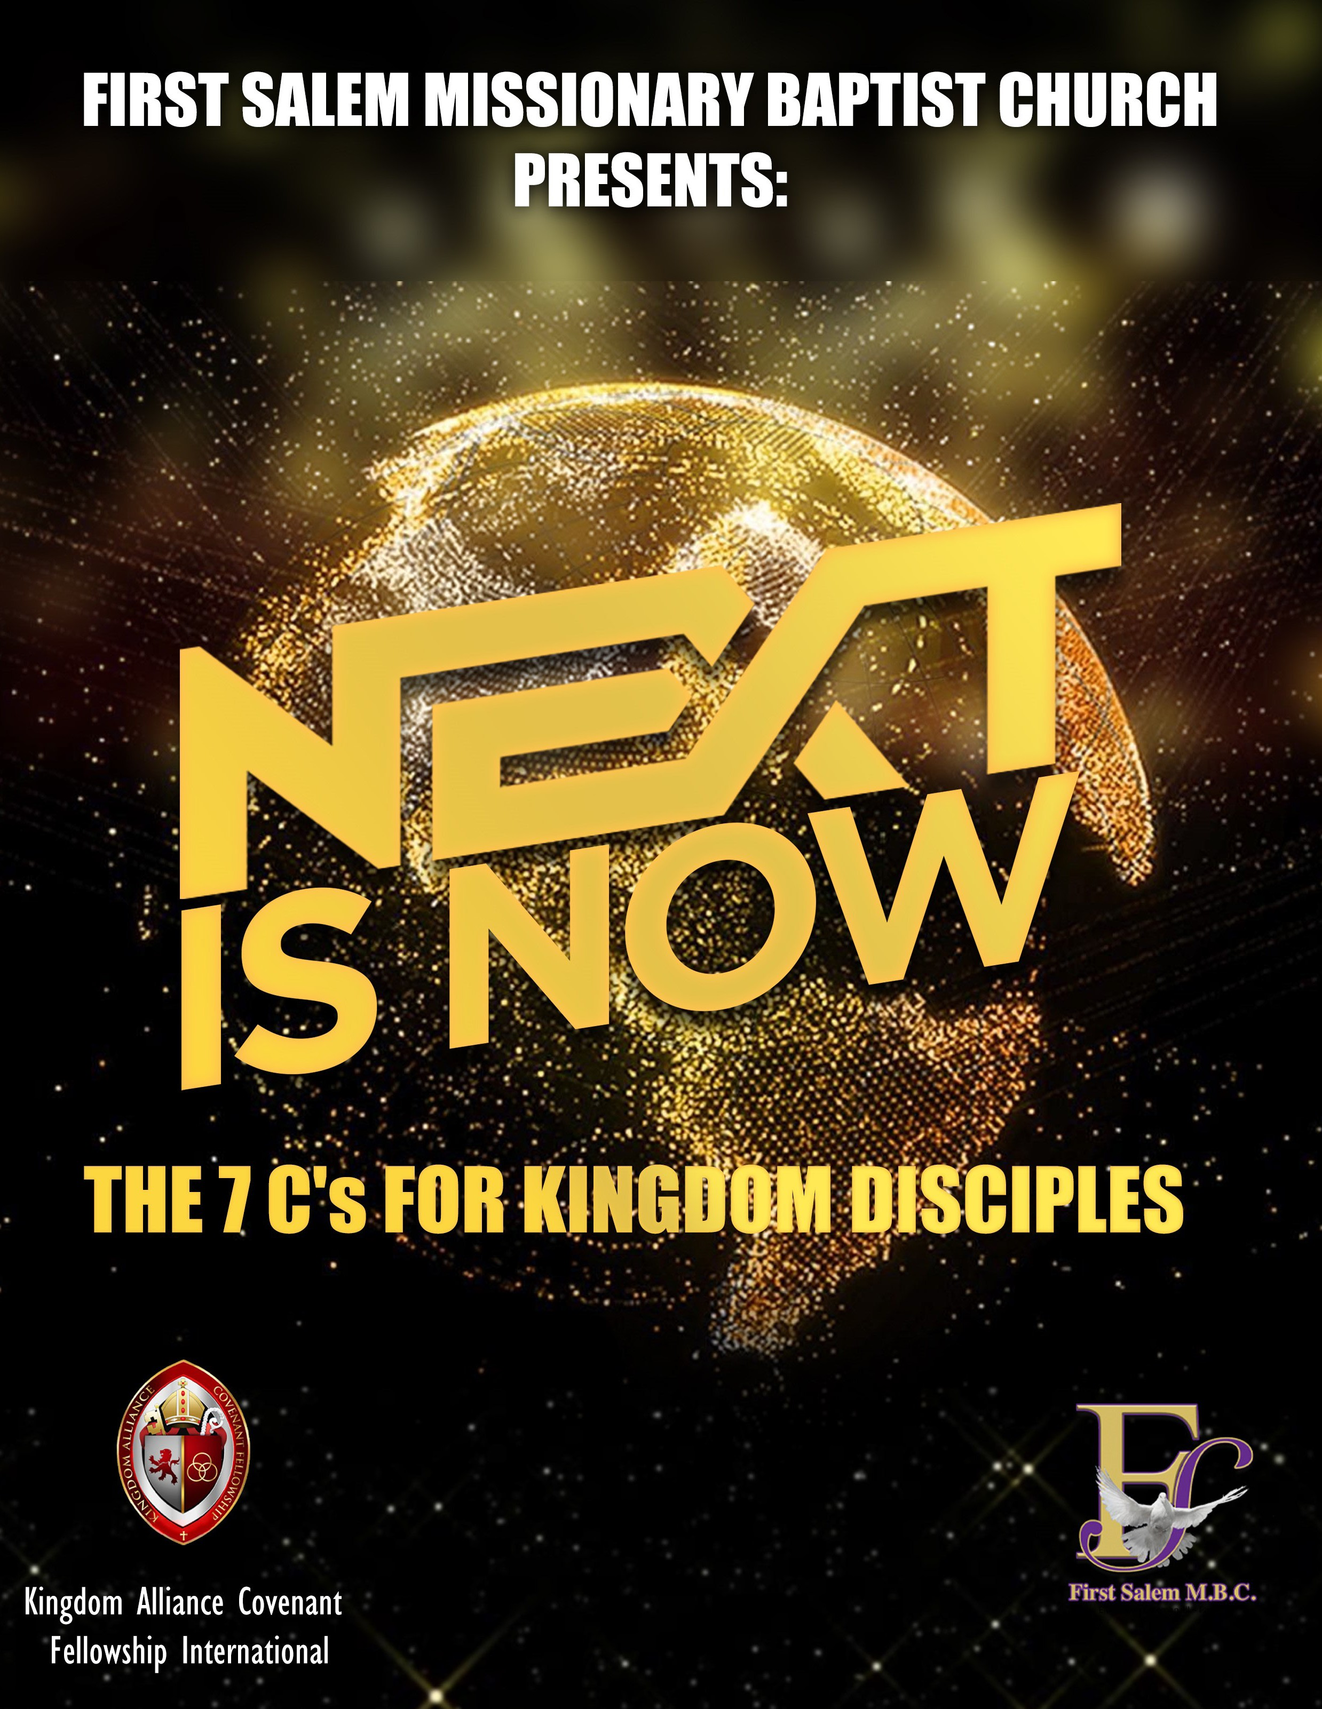

1

370 Capital Avenue SW Battle Creek, MI 49015 (269) 964-9637
Email: Firstsalemmbc@gmail.com Website: www.fsmbc.com

2021-2022 Theme:
Developing and Deploying Disciples for Kingdom Service

Mission:
Transforming Lives through the preaching, teaching, and witnessing of Gods’ Word

Office Hours: Tues-Fri.: 9a.m. –3p.m.

The Point: Recognizing the creative nature and power of God helps us to connect with the creative nature and power that is within each of us.

- An attribute/characteristic of God that is sometimes overlooked is the power of God. How many times is the word create, created, creative, or creation mentioned in Genesis chapters 1 and 2?

- What did God create during each day? After He created it, what did he speak over it?

- What did God use to create? In addition, what does this tell us about God’s word?

- Read Genesis 2:7. What is unique about the creation of man?

- According to Ephesians 2:10, we are God’s . God breathed His breath into man and made him a living soul. Because of this, creative power of God now dwells within . The outcome of this is that man has the ability to just like the one who created him.

You can’t use up creativity. The more you use, the more you have.
~Maya Angelou

- Creativity typically displays itself through , , , and . Each of these come from God, the creator of man, who placed each of these elements within us to use for a specific purpose in the earth.

- Read Exodus 35:30-35. What do we learn about Bezalel and Aholiab in this passage?

Personal Reflection and Notes

Creativity is God’s gift to us. Using our creativity is our gift back to God.
~Julia Cameron

The Point: Creativity did not stop with God. He intends for his creation to be creative as well.

- Creativity is well received and accepted in the world of business and industry; however, it is sometimes resisted in the church. In your opinion, why do you think that is?

- Read Exodus 4:1-9. What does the Lord ask Moses in verse 2? In addition, what three creative displays did God tell Moses to use if people did not believe that He was sent by God?

- God is stirring up the creativity within his sons and daughters through the power of His Holy Spirit. Your gifts, talents, skills and abilities are for such a time as this.

- Complete the “Gifts and Talents” Inventory provided with the workbook. Note some of the responses that you provided below. How might this information help to strengthen your local church and community?

- Fear of using the creativity that God has given you will cause the church to become
. What is the internal and external danger of stifling the creativity that God is looking to display through you?

The Creator made us creative. Our creativity is our gift from God. Our use of it is our gift to God. Accepting this bargain is the beginning of true self-acceptance.
~Julia Cameron

Background Scripture: Matthew 9:35-10:8 Memory Verses:
Then He said to His disciples, “The harvest truly is plentiful, but the laborers are few. Therefore, pray the Lord of the harvest to send out laborers into His harvest.”
~Matthew 9:37-38

The Point: As Kingdom disciples, when we engage in ministry and use the authority that has been given to us through Christ, it should be implemented with compassion. Jesus teaches us that our authority should have a component of grace attached to it.

- Provide a definition for the word compassion:

- What is Jesus doing through all the cities and villages, according to Matthew 9:35?

- Why was Jesus moved with compassion, according to verse 36?

- What does Jesus say to the disciples and what is He referring to throughout this passage?

- What does Jesus actually do, according to Matthew 10:1? What does he give them?

- Why did Jesus give the twelve disciples power?

Allow God to continually soften your heart so that it beats for what His heart beats for: people. ~Christine Caine

Background Scripture: Matthew 14:14-21 Memory Verse:
And He took the five loaves and the two fish, and looking up to heaven, He blessed and broke ang gave the loaves to the disciples; and the disciples gave to the multitudes.
~Matthew 14:18b

The Point: Kingdom disciples must be conduits of compassion in the earth.

- We find another occasion in which Jesus is moved with compassion in Matthew 14. What caused Jesus to be moved with compassion in this passage? In addition, how does He respond?

- Jesus continues to display compassion for the multitude by them. How does He do it?

- As disciples of Christ, we should engage in life through the lens of
towards others.

- As we compare Matthew 9:36 and 14:14, we see that Jesus’ heart is filled with compassion, and this compassion moved Him to .

- If we are going to have the compassion of Christ, then we need to
  - Know Christ’s :
  - Know humanities :
  - Know how Christ brought about :

- Has the Holy Spirit caused you to feel compassion toward something in this season? What is it? In addition, have you been moved to action in some way, or are you wondering what you should do next?

We must be instruments of God’s compassion to those who are suffering.
~Radhanath Swami

And the hand of the Lord was with them, and a great number believed and turned to the Lord.
~Acts 11:21

The Point: Kingdom disciples use setbacks as opportunities to advance the Kingdom of God.

- What caused the scattering of God’s people, according to Acts 11:19? Review Acts 7:54- 60 for further detail.

- What opportunities presented themselves because of the scattering of believers, according to verses 20-21?

- Barnabas gave a message of to the disciples in Antioch. His message encouraged them to with the Lord with devoted . Why was this important? (See NIV Bible version)

- Another result of the scattering of believers, coupled with the words of encouragement by Barnabas was what, according to verse 24?

- How long did Barnabas and Saul stay with the church in Antioch? What does this teach us?

- God used what some would say as a setback as a setup for the multiplication of believers in the earth. What can we learn from this passage of scripture as we think about evangelism and advancing the Kingdom of God?

And when he had found him, he brought him to Antioch. So it was that for a whole year they assembled with the church and taught a great many people. And the disciples were first called Christians in Antioch. ~Acts 11:26

The Point: Kingdom disciples use setbacks as opportunities to advance the Kingdom of God.

- The name Christian was ascribed to the worshippers of Christ by the Gentiles. At the onset, the name intended to represent a negative connotation, however, over time this name became one that was associated with acceptance and honor. Has your walk with Christ ever been looked upon by others negatively, but later looked at with honor or respect? Please explain below:

- The Gentiles called the people “Christian” because of what they saw. The Gentiles saw the people committing themselves to doing the following things: assembling in the church and being taught the word of God. Does your life also demonstrate this commitment? In what ways? Would others be able to say the same?

- What does it mean to be Christian? It requires commitment to do the following things:
  - Commitment to do the will of the Father—To glorify the Father in all things
(Matthew 5:16, 1 Corinthians 10:31, 1 John 5:14)

  - Commitment to adhere to the words of the Father—The Bible
(Luke 11:28, Matthew 7:24, James 1:22, Romans 10:17)

  - Commitment to living in the ways of the Father—
(The Fruit of the Spirit: Galatians 5:22-23, The Beatitudes: Matthew 5, The Mind of Christ: Philippians 2:5-11, Romans 12:2)

  - Commitment to producing the works of the Father—The Gifts of the Spirit:
(1 Corinthians 12, Romans 12; The Works of Christ: John 14:12, Ephesians 2:10)

  - Commitment to winning others to the Father, through Christ:
(Matthew 28:19, Acts 1:8, Romans 1:16, Jude 1:23)

Personal Reflection and Notes

Your life as a Christian should make non-believers question their disbelief in God.
~Dietrich Bonhoeffer

Next is Now: 7 Cs for the Kingdom Disciple

Lesson 4: Communicative, part 1
Background Scripture: John 4:1-30; 39-42 Memory Verse:
And many of the Samaritans of that city believed in Him because of the word of the woman who testified, “He told me all that I ever did.” ~John 4:39

The Point: Through the power of the Holy Spirit, even uncomfortable conversations can cause hearts to be turned to Christ…if we are willing to have them.

- In John 4:6-9 we read of a conversation between 2 individuals. Who begins this conversation, what does He ask, and what response does He receive?

- Why was there tension between Jesus and the woman? (Read 2 Kings 17:24-33 for historical context)

- Regardless of this tension, John 4:4 reveals that Jesus to go through Samaria. What does this teach us as we endeavor to be effective communicators of the gospel of Jesus Christ?

- How does Jesus shift the conversation with the woman? From an evangelistic perspective, how does Jesus’ approach help open the lines of communication with the woman?

- In the conversation, Jesus reveals that the two actually have something in common. Jesus was thirsty for water, but the woman was thirsty for .

- Jesus’ intent was not to bring shame upon the woman, however, after addressing the woman’s relationship issues, the woman changes the topic. How does Jesus bring clarity to the woman regarding worship and a meaningful relationship with the Father?

- Overall, how does this one conversation impact this this woman, and others?

Personal Reflection and Notes

Communicate. Even when it’s uncomfortable or uneasy. One of the best ways to heal, is simply getting everything out. ~Unknown

Next is Now: 7 Cs for the Kingdom Disciple

Lesson 4: Communicative, part 2
Background Scripture: John 4:1-30; 39-42
Memory Verse:
And many of the Samaritans of that city believed in Him because of the word of the woman who testified, “He told me all that I ever did.” ~John 4:39

The Point: While spreading the gospel can be challenging in a world that is saturated with bad news, Kingdom disciples must continue to communicate the gospel throughout the earth.

- The phrase “spread the word” means to communicate a message to a lot of people. Some people are really good at spreading information quickly. If you were planning an upcoming celebration (graduation party, wedding, or a birthday) and wanted a lot of people to attend, how would you spread the word?

- Studies have shown that false information, gossip, fake news and lies spread significantly farther and faster than the truth. Why do you think that more people are interested in gossip than they are in the total truth?

- The world is saturated and infatuated with bad news, fake news, and lies. How can we as believers effectively communicate the Good News to a world in spite of this?

- Jesus’ conversation with the woman at the well gives us tips on effectively spreading the Word of God. How did Jesus effectively engage with the woman and challenge her circumstance in life?

- Jesus’ conversation did 3 things:
  - Met the woman where she was
  - attempted to meet the immediate need of the woman
  - navigated the messiness of the woman’s life to help point her to a meaningful relationship with the Messiah.
How can this process be used for evangelism today?

- Think of someone specific and share some ways you might meet them where they are in order to effectively share the gospel. Note your thoughts below:

- How can the message of the gospel meet the most immediate need of the person that you are thinking about?

Personal Reflection and Notes

Each generation of the church in each setting has the responsibility of communicating the gospel in understandable terms, considering the language and thought-forms of that setting.
~Francis Schaeffer

The Point: The Holy Spirit is the source of competence in the Body of Christ.

Competent is defined as: having suitable or sufficient skill, knowledge, experience, etc., for some purpose; properly qualified. Every Kingdom disciple is made competent for service through the power of the Holy Spirit.

- Read Acts 2:1-11. What did the Holy Spirit enable the people in the upper room to do? In addition, what did the multitude say they heard?

- After the Holy Spirit fell upon those in the upper room, baptizing and filling each of them, there were questions and comments among the community about what was going on. Who stands up to address the questions and why is this significant?

- According to Acts 2:41, what happened as a result of Peter’s sermon?

- While this competency or ability was given by the Holy Spirit, what does verse 42 state that the believers did in order to nurture and develop their relationship with God and with their brothers and sisters in Christ?

- What did the believers continue to do in Acts 2:46? In addition, what was the result?

God will call you outside of your comfort, not your competency. ~Steven Furtick

The Point: The Holy Spirit is the source of competence in the Body of Christ.

- It is the enabling power of the that equips us with skills, knowledge, gifts and abilities that are intended to be used to advance the Kingdom of God in the earth.

- While our Heavenly Father has placed skills, knowledge, gifts and abilities within each and every one of us, it is our responsibility to and them with the resources that He has made available to us.

- In 2 Timothy 3:10-17 the apostle Paul is admonishing Timothy to remain competent in his knowledge of the scriptures. Read verse 17. What is Paul’s reason for giving telling Timothy this?

- Do you feel that being skilled or competent in the ministry context makes the church too business-minded? Please explain your answer below:

- How can an individual develop competency in the skills, knowledge, gifts and abilities that they possess?

- Think about what God has placed inside of you to advance the Kingdom of God. What are you doing to cultivate or develop your gifts, talents, skills and abilities? What additional support do you need to move forward in developing and utilizing them?

The Point: The Holy Spirit empowers Kingdom Disciples to be change agents in the earth.

Change agents for the Kingdom of God are secure in their own personal conviction, willing to endure hardships for the sake of the mission, and intend to be effective witnesses even in the face of opposition.

- According to Acts 4:1-3, why were Peter and John arrested?

- In spite of their arrest, the impact of Peter and John’s preaching was already made. According to verse 4, what was the impact of their ministry?

- The rulers, elders, scribes and others begin to question Peter and John in verses 5-7. What is their question? In addition, summarize Peter’s response.

- After Peter’s response, the Sanhedrin notice a number of things. Read verses 13 and 14 and identify what they notice, as well as their ultimate response to it. (see verses 15-17)

- The Sanhedrin make one final command in verse 18. What response do Peter and John give to them in return? In addition, what prevented the Sanhedrin from punishing them, according to verses 21-22?

We have been created for God and by God to transform the world around us.
~Christine Caine

Lesson 6: Change Agent, part 2 Background Scripture: Acts 4:1-22 Memory Verse:
Now when they saw the boldness of Peter and John, and perceived that they were uneducated and untrained men, they marveled. And they realized that they had been with Jesus. ~Acts 4:13 The Point: The Holy Spirit empowers Kingdom Disciples to be change agents in the earth.

- Think about what it means to be a change agent. What are some qualities that they possess that enables them to bring about change? In addition, provide some examples of people throughout history that you would identify as a change agent.

- Peter and John were empowered by the Holy Spirit to be change agents in the earth. This responsibility, however, was often met with resistance by those who wanted to stop what they were doing. Reflect on Acts 4:1-11. Note how Peter and John handled the situation that they faced. How does that influence your thinking about handling resistance when doing what God has called you to do?

- The Sanhedrin used intimidation to try to stop the move of God working through Peter and John. Intimidation is still used today by the enemy to stop progress. Has intimidation ever been used against you in some capacity? Discuss below. In addition, how should a Kingdom disciple handle intimidation?

- Read Acts 4:23-31. Peter and John returned to their companions after being released. Review verse 29. Note what they pray for below. Why would this type of prayer request be essential for Kingdom disciples to replicate even today?

- God has empowered us to be His change agents in the earth. What challenges are you facing that may be hindering or intimidating you from fulfilling this assignment? Draft a prayer that addresses this concern, and believe God for results.

The Point: The Holy Spirit has enabled Kingdom disciples across all generations to be His witnesses in the earth. Together, we are empowered to impact the world for Jesus Christ.

- In Acts 2:14-18 Peter is addressing questions concerning the outpouring of the Holy Spirit. He brings clarity in verses 14-16. What does he say is and is not happening? Why is this important?

- Peter points the crowd to scripture in verses 17-21. (See Joel 2:28-32). What does the scripture say will happen in the last days, and who will be involved? (Focus on verses 17- 18) Why is this significant?

- Based upon what Peter is preaching, the Holy Spirit is available and accessible to
of His sons and daughters.

- Not only are people involved with the pouring out of the Holy Spirit, but all creation as well. What else will happen in heaven and earth in the last days, according to verses 19- 20?

- Acts 2:21 states an outcome of the Holy Spirit being poured out in the earth. What does it say? In addition, skip to verse 41. What is the result of Peter’s message?

From generation to generation, the spiritual church is rising upwards towards its perfection; and, though one after another the workmen pass away, the fabric remains, and the great Master-builder carries on the undertaking. Be it ours to build in our portion in a solid and substantial manner, so that they who come after us may be at once thankful for our thoroughness, and inspired by our example.
~William Mackergo Taylor

The Point: The Holy Spirit has enabled Kingdom disciples across all generations to be His witnesses in the earth. Together, we are empowered to impact the world for Jesus Christ.

- Peter’s message on the day of Pentecost includes God’s desire to empower all of His servants with His Holy Spirit. When you think about that word “all,” what comes to mind?

- Peter’s message highlights the cross-generational intention of our heavenly Father. The United States uses 7 different names to identify generations:
  - The Greatest Generation (1901-1927)
  - The Silent Generation (1928-1945)
  - Baby Boomers (1946-1964)
  - Generation X (1965-1980)
  - Millennials (1981-1995)
  - Generation Z (1996-2010)
  - Generation Alpha (2011-2025)
What generation do you fall in? In addition, what is the benefit of having representation from all accessible generations empowered with the Holy Spirit in the local church and throughout the world?

- In your opinion, what does a cross-generational church look like? In addition, what suggestions can you provide that will help us continue to engage in ministry that is cross-generational in nature?

- Sometimes differences and nuances between generations can cause division rather than create collective unity and power. What are some issues that we need to address between generations that will assist the church in operating in the power of the Holy Spirit collectively?

- Developing cross-generation Kingdom disciples requires the continual instruction in the word of God. Review Deuteronomy 6. Note the following:
  - Cross-generational ministry requires devotion (Deu 6:1-5)

  - Cross-generational ministry requires demonstration (Deu 6:7-9)

  - Cross-generational ministry requires discussion (Deu 6:20-25)

A cross-generational church is one that connects generations, fostering loving relationships between each one. Each generation feeds upon and from one another and esteems the other in love. With this formula, the foundations of the faith are passed down from one generation to another, which impacts the church, the community and the world for the glory of God.

First Salem MBC would like to thank the Bishop Edgar L. Vann, II along with the writing and editing team of the Kingdom Alliance Covenant Fellowship, International for their research contribution to this material.

First Salem Missionary Baptist Church:
A Kingdom Focused, Christ-Driven Ministry For All Mankind

Weekly Worship Schedule Disciple Empowerment Academy “DEA”
Tuesday (every other week) 6:00-7:15p.m.

Word on Wednesdays
Word on Wednesdays
“WOW”
6p.m.– 7:15p.m.

“WOW”
12 noon–1p.m. 6p.m.– 7:15p.m.

Sunday Church School
Sunday Church
School
9a.m.– 9:45a.m.

9a.m.– 10a.m.
Sunday Worship Experience 10:00a.m

Social Media Instagram: FirstSalemMbc Facebook: Firstsalemmbc Twitter: FirstSalemBCMI

